**Tkinter**

1. To check whether its installed –

Python –m tkinter

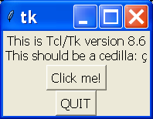

1. One.py

import tkinter

top = tkinter.Tk()

top.mainloop()

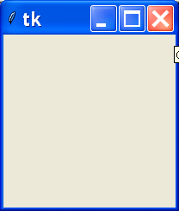

1. Two.py

import tkinter

import tkinter.messagebox

top = tkinter.Tk()

def helloCallBack():

tkinter.messagebox.showinfo( "Hello Python", "Hello World")

B = tkinter.Button(top, text ="Hello", command = helloCallBack)

B.pack()

top.mainloop()

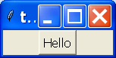 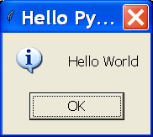

1. Three.py

from tkinter import *

root = Tk()

frame = Frame(root)

frame.pack()

bottomframe = Frame(root)

bottomframe.pack( side = BOTTOM )

redbutton = Button(frame, text="Red", fg="red")

redbutton.pack( side = LEFT)

greenbutton = Button(frame, text="Brown", fg="brown")

greenbutton.pack( side = LEFT )

bluebutton = Button(frame, text="Blue", fg="blue")

bluebutton.pack( side = LEFT )

blackbutton = Button(bottomframe, text="Black", fg="black")

blackbutton.pack( side = BOTTOM)

root.mainloop()

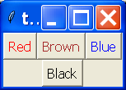

1. Five.py

from tkinter import *

root = Tk()

var = StringVar()

label = Label( root, textvariable=var, relief=RAISED )

var.set("Hey!? How are you doing?")

label.pack()

root.mainloop()

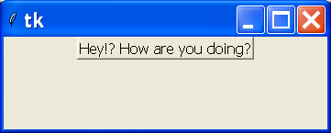

1. Six.py

from tkinter import *

def sel():

selection = "You selected the option " + str(var.get())

label.config(text = selection)

root = Tk()

var = IntVar()

R1 = Radiobutton(root, text="Option 1", variable=var, value=1,

command=sel)

R1.pack( anchor = W )

R2 = Radiobutton(root, text="Option 2", variable=var, value=2,

command=sel)

R2.pack( anchor = W )

R3 = Radiobutton(root, text="Option 3", variable=var, value=3,

command=sel)

R3.pack( anchor = W)

label = Label(root)

label.pack()

root.mainloop()

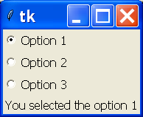

1. Seven.py

from tkinter import *

def sel():

selection = "You selected the option " + str(var.get())

label.config(text = selection)

text.insert(END, selection)

root = Tk()

var = IntVar()

R1 = Radiobutton(root, text="Option 1", variable=var, value=1,

command=sel)

R1.pack( anchor = W )

R2 = Radiobutton(root, text="Option 2", variable=var, value=2,

command=sel)

R2.pack( anchor = W )

R3 = Radiobutton(root, text="Option 3", variable=var, value=3,

command=sel)

R3.pack( anchor = W)

label = Label(root)

label.pack(anchor=W)

text = Text(root, width=30, height=1 )

text.pack(anchor=W)

root.mainloop()

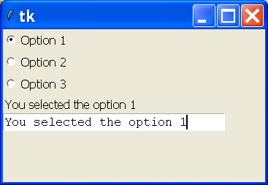

1. Eight.py

from tkinter import *

top = Tk()

L1 = Label(top, text="User Name")

L1.pack( side = LEFT)

E1 = Entry(top, bd =5)

E1.pack(side = RIGHT)

top.mainloop()

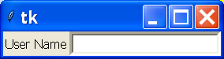

1. Nine.py

from tkinter import *

top = Tk()

CheckVar1 = IntVar()

CheckVar2 = IntVar()

C1 = Checkbutton(top, text = "Music", variable = CheckVar1, \

onvalue = 1, offvalue = 0, height=5, \

width = 20)

C2 = Checkbutton(top, text = "Video", variable = CheckVar2, \

onvalue = 1, offvalue = 0, height=5, \

width = 20)

C1.pack()

C2.pack()

top.mainloop()

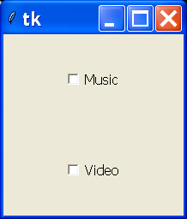

**Database Connectivity**

1. Step 1 – installing mysql-python driver
2. Db1.py

import mysql.connector

db = mysql.connector.connect(user='root', password='', host='127.0.0.1', database='test')

cursor = db.cursor()

cursor.execute("SELECT VERSION()")

data = cursor.fetchone()

print ("Database version : %s " % data)

db.close()

1. Db2.py

import mysql.connector

db = mysql.connector.connect(user='root', password='', host='127.0.0.1', database='test')

cursor = db.cursor()

cursor.execute("create table e2( roll integer)")

cursor.execute("select count(*) from students")

data = cursor.fetchone()

print ("Database version : %s " % data)

db.close()

1. Db4.py

import mysql.connector

db = mysql.connector.connect(user='root', password='', host='127.0.0.1', database='test')

cursor = db.cursor()

cursor.execute("select * from students")

results = cursor.fetchall()

for row in results:

x = row[0]

y = row[1]

print(x ," " , y)

db.close()